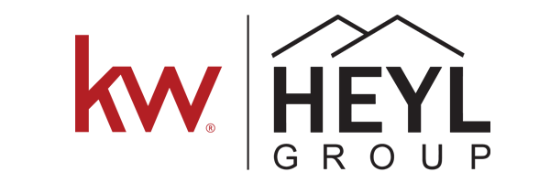

BOOMTOWN Definitions and Laws

Boomtown Definitions

Nurture- Lead we have spoken with, has detailed notes.

New- Lead that is untouched, just came in.

Qualify- Lead we have tried to reach but have not gotten ahold of yet.

Hot- appointment set with lead

Pending- Client Taken (listing agreement or Buyer rep)

Closed- Client has bought or sold their home

Watch- Bad number, only have an email.

Archive- Have tried a number of times to reach but have not connected with recently or at all. Either have spoken to them and were originally a Nurture or was a qualify lead we have never reached.

Trash- Confirmed they are no longer transacting. Detailed notes on whey they are not.

Laws of the pipeline

1) NEW leads must be changed to NURTURE or HOT within 12 hours of receipt.

2) May Keep up to a total of 100 NURTURES in your pipeline at a given time.

3) No leads in QUALIFY

4) Any lead moved to NURTURE must have sufficient notes why it was changed to NURTURE

5) Any lead moved to TRASH must have a detailed note that explains why it was moved to TRASH

6) All HOT and NURTURE leads must have a to-do set at all times.

7) NO past dues in TO-Do’s

